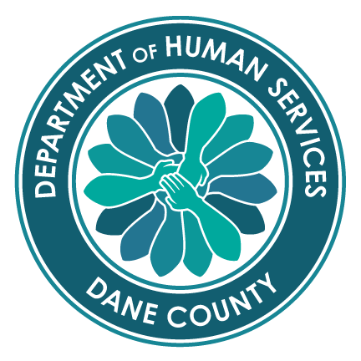
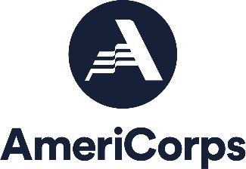
Partners for After School Success (PASS)

A Community-Based AmeriCorps Program

Dane County Department of Human Services
Division of Children, Youth & Families

PASS AMERICORPS MEMBER 1700 Hour POSITION DESCRIPTION
Position Summary:
PASS AmeriCorps members are responsible for serving youth at agencies or school sites throughout Dane County. PASS activities include school engagement activities and tutoring; engaging youth in community service; and providing extended learning programs including employment skill training. In addition to agency responsibilities, PASS AmeriCorps members engage in professional development activities and participate in national and/or local community service projects and AmeriCorps events.

AmeriCorps Requirements: AmeriCorps members must meet the following requirements outlined by the State and Federal AmeriCorps rules, including:
1) Serve 1700 hours by August 23
2) Be a citizen of the United States, a United States national, or a legal permanent resident of the United States
- Have a high school degree or equivalent (or agrees to obtain a high school diploma or GED)
- Be a least 17 years old
- Pass a criminal background check including National Sex Offender Registry, State(s) registry and FBI
- Have not served more than four fulltime AmeriCorps terms of service or received two fulltime education awards
- Follow all PASS policies and AmeriCorps rules and regulations as outlined in the Member Agreement

PASS Requirements--Youth Work: PASS AmeriCorps members spend at least 80% of their time providing services to youth at a host site located in Dane County. PASS service activities include school engagement activities & tutoring, developing and facilitating extended learning programs during or after school, and engaging youth and adult volunteers in community service.
Requirements include:
- Complete a Work Plan that outlines professional goals and a schedule to provide PASS program activities
- Provide school engagement activities & tutoring, develop and facilitate extended learning programs, engage youth in community service
- Understand and actively contribute to PASS meeting its program performance measures
- Complete regular reporting in MOST MIS system related to PASS service activities and performance measures
- Serve as a positive adult role model for youth
- Maintain appropriate boundaries and conduct with youth (a vulnerable population) at all times
- Respect youth cultural differences

PASS Requirements—Host Site team member
- Be punctual and follow assigned work schedule
- Learn and follow host site policies and procedures
- Provide own transportation to host site (some sites on bus routes)
- Set regular consultation and reflection times with supervisor (weekly meetings)
- Keep direct supervisor informed about concerns, conflicts or problems
- Complete tasks as assigned in an accurate and timely manner include entry of service hours
- Be a cooperative team member
- Enter service hours in On Corps in an accurate and timely manner

PASS Requirements—Professional Development/Community Service: PASS AmeriCorps members spend approximately 20% of their time collaborating with other AmeriCorps members on community service or professional development activities. Requirements to this end include:
- Participate in Serve Wisconsin AmeriCorps events
- Participate in citizenship training provided by PASS and group service events
- Participate in professional development meetings
- Participate in at least one national day of service (i.e. September 11, MLK Day, Global Youth Service Day)
- Participate in local or regional natural disasters as needed and Alternative Spring Break service week (optional)

