Good afternoon, Amy My name is Paul Skoglind with MTM’s Community Outreach Team. I was referred your contact information and with request to provide information pertaining to reimbursement for Gas Mileage Reimbursement, including the

ZjQcmQRYFpfptBannerStart

**MTM Gas Mileage Reimbursement and Payment Preferences**

With the Gas Mileage Reimbursement program, members, friends, and family can be reimbursed for taking the member to Medicaid covered appointments.

***There are three options for reimbursement available to payees***:

1. Reloadable Debit Card (US Bank Card)
2. Direct Deposit
3. Paper Check

US Bank is the source of the reloadable debit card and is a trusted source for reimbursement.  This reloadable debit card is the default for any payee without other preference specified.

Typically, the MTM gas cards are activated via an automatic online process. The automated call asks for: the last 4 digits of the card (and sometimes the CVV), the phone number associated, and then either date of birth or SSN.

However, this disclaimer is also present on the US Bank information on MTM’s website:

*“Important Information About Opening a New Account”*

*“To help the government fight the funding of terrorism and money laundering activities, federal law requires all financial institutions to obtain, verify, and record information that identifies each person who opens an account. What this means for you: When you open an account, we will ask for your name, street address, date of birth, and other information that allows us to identify you. We may also ask to see your driver’s license or other identifying documents.”*

If the member or payee are not comfortable with the US Bank Card, they can also have reimbursement preferences of Direct Deposit or Paper Check.  The most efficient way for members and payees to change their payment preference is via the MTM Link Member App.  This can be downloaded on their phone, which allows for quick and easy management of the GMR payee preferences.

The member/payee may also utilize the resources online, which have instructions on how to change payment preferences:

* MTM Link Member App
* There is also helpful information on the MTM-Wisconsin website with information on the link Member App and changing payment preferences for GMR reimbursement: [Wisconsin Non-Emergency Medical Transportation - NEMT (mtm-inc.net)](https://www.mtm-inc.net/Wisconsin/)
* At the Members tab, is the GMR and payment preferences pictured below:

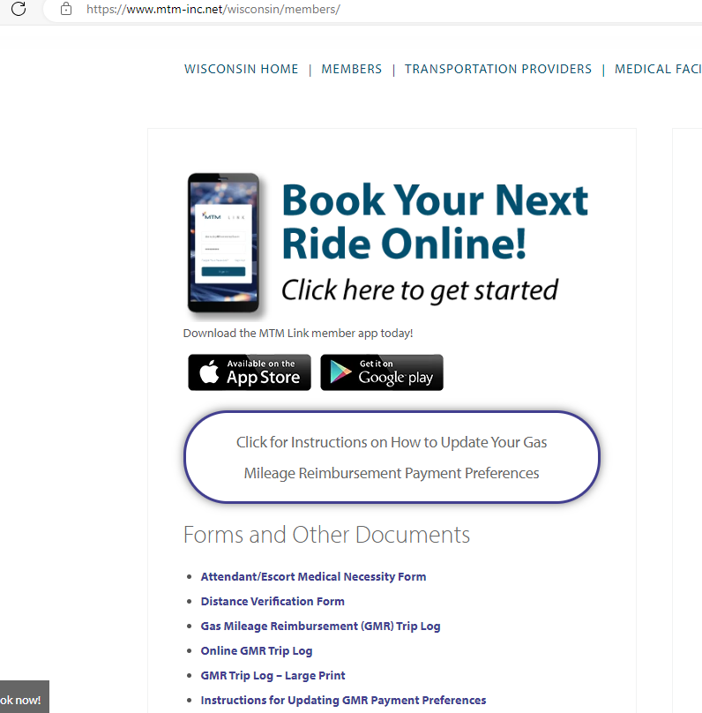

MTM’s Contact Center is available to answer any questions that members and families may have pertaining to trips and reimbursement.  Below is the MTM Reservation Line and link to Live Chat

* Reservation Line: 866-907-1493
* [Wisconsin Non-Emergency Medical Transportation - NEMT (mtm-inc.net)](https://www.mtm-inc.net/Wisconsin/)